Six Week Hands on Training
On
NextGen AI Bootcamp:
Agents, Intelligence & Games Using Python
With
Projects
At
Thapar Polytechnic College, Patiala
SUBMITTED IN PARTIAL FULFILMENT OF THE REQUIREMENT FOR THE AWARD OF THE DIPLOMA IN
COMPUTER SCIENCE AND ENGINEERING
Submitted by:
NAME: Anshuman Aggarwal
ROLL NO: 2024/352

UNDER THE GUIDANCE OF:
Er. Ankur Thakur
Er. Harjeet Singh
Dr. Kirandeep Kaur
DEPARTMENT OF COMPUTER SCIENCE AND ENGINEERING
June 2026

CERTIFICATE

ACKNOWLEDGEMENT
I would like to express my sincere gratitude to everyone who supported and guided me during my six-week industrial training, which was undertaken as a part of the Diploma in Computer Science and Engineering.
I am thankful to my institution for providing me with the opportunity to participate in this training program. It offered me valuable practical exposure, enabling me to apply my academic knowledge in real-world situations and develop a better understanding of industry practices.
I would like to convey my heartfelt appreciation to my training mentors, Mr. Ankur Thakur, Mr. Harjeet Singh, and Ms. Kirandeep Kaur, for their constant guidance, encouragement, and constructive suggestions throughout the training. Their support played an important role in enhancing my technical skills and confidence.
I am also grateful to the faculty members and the Department of Computer Science and Engineering at Thapar Polytechnic College for organizing this training and inspiring me to continue learning and improving my abilities.
Lastly, I extend my sincere thanks to my family and friends for their unwavering encouragement, motivation, and support throughout this learning experience. This training has been an important milestone in my academic and professional journey, and I am deeply thankful to everyone who contributed to making it a rewarding experience.

Anshuman Aggarwal
Diploma in Computer Science and Engineering
2024/352
Thapar Polytechnic College

DECLARATION
I hereby declare that the training report entitled "Python Powered Projects: AI to Arcade" is an original record of the work completed by me during the six-week training program conducted at Thapar Polytechnic College from 23 June 2025 to 1 August 2025, as a part of the curriculum for the Diploma in Computer Science and Engineering.

I further declare that this report has not been submitted, either wholly or partially, to any other institution or university for the award of any degree, diploma, or certificate. The work presented in this report is based on my own learning, practical implementation, and experience gained during the training under the guidance and supervision of Mr. Ankur Thakur, Mr. Harjeet Singh, and Ms. Kirandeep Kaur.

I also confirm that all sources of information, references, and assistance received during the preparation of this report have been appropriately acknowledged wherever required.

Anshuman Aggarwal
Diploma in Computer Science and Engineering
2024/352
Thapar Polytechnic College

INSTITUTIONAL PROFILE
Thapar Polytechnic College
Thapar Polytechnic College (TPC), Patiala, was established in 1956 through the vision and dedication of Late Lala Karam Chand Thapar, with the support of Maharaja Yadavindra Singh of the former PEPSU State. Over the years, the institution has earned a strong reputation for providing quality technical education and producing skilled diploma engineers.
TPC is one of the three institutions located on the Thapar Technology Campus, alongside the Thapar Institute of Engineering and Technology (TIET) and the Thapar Centre for Industrial Research and Development (TCIRD). The college is a government-aided, privately managed institution affiliated with the Punjab State Board of Technical Education and Industrial Training (PSBTE & IT), Chandigarh.
Since its inception, the college has continuously expanded its academic programs and infrastructure to meet the evolving needs of technical education. It currently offers three-year diploma programs in five engineering disciplines and has consistently maintained high academic standards. In recognition of its excellence, Thapar Polytechnic College was awarded the title of Best Polytechnic in the Northern Region during the academic years 1999–2000 and 2005–2006.
Departments
The college offers diploma programs in the following departments:
- Computer Science and Engineering
- Architectural Assistantship
- Civil Engineering
- Electrical Engineering
- Mechanical Engineering
History
Thapar Polytechnic College began its journey in 1956 by offering three-year diploma courses in Civil Engineering, Electrical Engineering, and Mechanical Engineering with an initial intake of 60 students. As technical education gained importance, the institution expanded its academic offerings by introducing Computer Science and Engineering and Architectural Assistantship, increasing its annual student intake significantly.
Today, the college is recognized as one of the leading polytechnic institutions in the region. With experienced faculty members, modern laboratories, well-equipped workshops, library facilities, and a strong emphasis on practical learning, TPC provides students with the technical knowledge and professional skills required to succeed in industry and higher education. The institution continues to uphold its commitment to academic excellence, innovation, and holistic student development.

ABSTRACT
This report provides a detailed overview of the six-week industrial training titled "Python Powered Projects: AI to Arcade", undertaken as part of the Diploma in Computer Science and Engineering curriculum. The primary objective of the training was to strengthen both theoretical understanding and practical skills in Python programming while gaining hands-on experience in developing real-world applications.
During the training, a wide range of Python concepts were covered, including data types, operators, control statements, functions, modules, file handling, exception handling, and object-oriented programming. The training emphasized practical implementation through coding exercises and project-based learning, enabling the application of programming concepts to solve real-world problems.
In addition to the core language features, the training introduced several important Python libraries such as NumPy, Pandas, OpenCV, Tkinter, and TensorFlow, providing exposure to fields including data analysis, computer vision, graphical user interface (GUI) development, and artificial intelligence. Multiple mini-projects and application-based assignments were completed to improve logical thinking, programming efficiency, debugging skills, and problem-solving abilities.
This report summarizes the concepts studied, projects developed, and practical knowledge acquired throughout the training period. The experience has significantly improved my technical competence, programming confidence, and analytical skills. It has also established a strong foundation for future learning and development in advanced areas such as machine learning, artificial intelligence, data science, web development, and automation using Python.

Table of Contents
CHAPTER 1: INTRODUCTION TO PYTHON 1
1.1 PYTHON 1
1.2 FEATURES OF PYTHON 1
1.3 ADVANTAGES OF PYTHON 2
1.4 DATATYPES 2
1.5 DICTIONARIES 3
1.6 SETS 3
1.7 CONDITIONAL STATEMENTS 4
1.8 MODULES 4
1.10 CLASSES AND OBJECTS 5
CHAPTER 2: MACHINE LEARNING 7
2.1 MACHINE LEARNING 7
2.2 HOW MACHINE LEARNING WORKS 7
2.3 APPLICATION OF MACHINE LEARNING 8
2.4 FEATURES OF MACHINE LEARNING 8
2.5 ADVANTAGES OF MACHINE LEARNING 8
2.6 LIBRARIES IN MACHINE LEARNING 9
CHAPTER 3: DEEP LEARNING 12
3.1 DEEP LEARNING 12
3.2 HOW DEEP LEARNING WORKS? 12
3.3 APPLICATION OF DEEP LEARNING 13
3.4 FEATURES OF DEEP LEARNING 13
3.5 ADVANTAGES OF DEEP LEARNING 14
3.6 LIBRARIES IN DEEP LEARNING 14
3.7 CNN 16
3.8 RNN 17
CHAPTER 4: GAMING 18
4.1 ABOUT GAMING 18
4.2 POPULAR LIBRARIES FOR GAME DEVELOPMENT IN PYTHON 18
CHAPTER 5: INTRODUCTION TO AI 22
5.1 ARTIFICIAL INTELLIGENCE 22
5.2 WORKING OF ARTIFICIAL INTELLIGENCE 22
5.3 APPLICATIONS OF ARTIFICIAL INTELLIGENCE 23
5.4 TYPES OF ARTIFICIAL INTELLIGENCE 23
5.5 LLM 24
5.6 AI AGENT 25
5.7 AGENTIC AI 25
CHAPTER 6: PROJECTS IN PYTHON 26
6.1 HANGMAN GAME 26
6.2 CLASSIFICATION OF IRIS FLOWER IN MACHINE LEARNING 30
6.3 HANDWRITTEN DIGIT CLASSIFICATION IN DEEP LEARNING 32
CHAPTER 7: MAJOR PROJECT – PROBOT AI: AI-BASED DESKTOP RESEARCH LIBRARY AND INTELLIGENT KNOWLEDGE DISCOVERY SYSTEM 36
7.1 INTRODUCTION & PROJECT OVERVIEW 36
7.2 SENTENCE-TRANSFORMERS & SPACY NLP DEEP LEARNING MODELS FOR SEMANTIC SEARCH 39
7.3 TF-IDF & HEURISTIC MACHINE LEARNING ALGORITHMS FOR CONCEPT MAPPING & INTENT ENGINES 40
7.4 OLLAMA PHI-3 MINI LLM INTEGRATION & RETRIEVAL-AUGMENTED GENERATION (RAG) AI ASSISTANT 42
7.5 DASHBOARD, ANALYTICS, & LEDGER SYSTEM 44
7.6 SYSTEM IMPLEMENTATION & TECHNICAL STACK SUMMARY 46
CONCLUSION 48
REFERENCES 49

CHAPTER 1: INTRODUCTION TO PYTHON

1.1 PYTHON
Python is a high-level, general-purpose programming language developed by Guido van Rossum and was officially released in 1991. Designed with a strong emphasis on code readability, it has become one of the premier languages introduced to students and beginners today. Writing code in Python closely resembles writing plain English, eliminating much of the syntactic complexity—such as excessive brackets and semicolons—found in traditional programming languages. This simplicity enables developers to focus primarily on problem-solving rather than struggling with intricate syntax rules.
During my six-week training program at Thapar Polytechnic College, Python served as the foundational language for every domain we explored, including machine learning, deep learning, and game development. Developing a solid grasp of core Python concepts made transitioning into these advanced domains seamless, as their underlying frameworks and libraries are built directly on top of Python.

1.2 FEATURES OF PYTHON
The key features of Python emphasized during the training include:
- Easy to Learn and Read: Python features a clean, intuitive syntax close to natural English, making it highly accessible to beginners.
- Interpreted Language: Python code is executed line by line, which simplifies debugging since runtime errors are identified immediately.
- Free and Open Source: Python is freely available for anyone to download, execute, and modify without licensing fees.
- Cross-Platform Portability: Python programs written on one operating system (such as Windows) can run seamlessly on Linux or macOS without requiring code modifications.
- Extensive Library Ecosystem: Python offers a rich standard library alongside thousands of third-party packages, covering domains from web development to data analytics.
- Multi-Paradigm Support: Python supports procedural, object-oriented, and functional programming paradigms, offering developers high flexibility in system design.

1.3 ADVANTAGES OF PYTHON
Beyond its core features, Python delivers several practical benefits that make it an industry standard:
- Concise Codebase: Tasks require significantly fewer lines of code compared to compiled languages like C or Java, accelerating development time.
- Vibrant Community Support: A massive, active global community ensures extensive documentation, tutorials, and pre-built solutions are readily accessible online.
- Industry Dominance in Emerging Tech: Python is the primary language for Artificial Intelligence, Machine Learning, Data Science, and Automation, unlocking broad career opportunities.
- Seamless Integration: Python integrates easily with legacy codebases written in C, C++, or Java, making it ideal for enterprise-scale software.
- Robust Web Frameworks: Advanced frameworks such as Django and Flask streamline web development by enforcing structured, rapid application design.

1.4 DATATYPES
In Python, a data type defines the classification of a variable's value, specifying the operations that can be performed on it. Unlike statically typed languages, Python does not require explicit variable declaration; instead, the data type is inferred dynamically at runtime when a value is assigned. This feature is known as dynamic typing. The primary data types covered during the training include:
- int: Represents whole numbers (e.g., 10, -25, 100).
- float: Represents floating-point numbers with real values (e.g., 3.14, -0.5).
- str: Represents textual data enclosed in single or double quotes (e.g., "Python").
- bool: Represents logical values (True or False).
- list, tuple, dict, set: Represent structured collections used to store multiple data items efficiently.
Python
x = 10 # int
y = 3.5 # float
name = "Anshuman" # str
is_valid = True # bool
print(type(x), type(y), type(name), type(is_valid))

1.5 DICTIONARIES
A dictionary in Python is an unordered collection that stores data in key-value pairs, rather than indexed values like a list. Every key within a dictionary must be unique, serving as a direct reference to retrieve its corresponding value. Dictionaries are ideal for structured records where data elements are best referenced by descriptive labels rather than numerical indices (such as storing a student's personal details).
Python
student = {
"name": "Anshuman",
"course": "CSE Diploma",
"semester": 5
}
print(student["name"]) # Output: Anshuman
student["marks"] = 92 # Adding a new key-value pair
During the training, we practiced essential dictionary operations, including inserting new pairs, updating existing entries, deleting records using the del keyword, and iterating through key-value sets using the. items() method.

1.6 SETS
A set is an unordered collection composed entirely of unique elements. Sets automatically eliminate duplicate entries, making them ideal for processing distinct datasets, such as extracting unique course enrollments from a raw, repetitive list.
Python
languages = {"python", "java", "python", "c"}
print(languages) # Output: {'python', 'java', 'c'}
languages.add("c++")
print("java" in languages) # Output: True
We also implemented mathematical set operations such as union, intersection, and difference to compare datasets effectively—for instance, determining overlapping courses between two distinct student schedules.

1.7 CONDITIONAL STATEMENTS
Conditional statements allow a program to evaluate logic dynamically and execute specific code blocks depending on whether a condition evaluates True or False. Python utilizes the if, Elif, and else keywords for decision-making. Instead of using traditional curly braces, Python relies strictly on indentation to define code blocks.
Python
marks = 78
if marks >= 90:
print ("Grade A")
elif marks >= 75:
print ("Grade B")
else:
print ("Grade C")
Conditional execution forms the backbone of modern program design. In practice, real-world applications—ranging from machine learning algorithms classifying data to gaming logic tracking player scores—rely directly on conditional structures.

1.8 MODULES
A module in Python is a file containing executable code—such as functions, classes, or variables—designed to be imported and reused across multiple programs. Python features a comprehensive built-in standard library containing modules like math, random, and datetime. Additionally, external modules can be managed via the package manager pip, or created manually as custom utility files.
Python
import math
import random
print(math.sqrt(25)) # Output: 5.0
print(random.randint(1, 6)) # Output: Random integer between 1 and 6
Modular design encourages clean, maintainable architecture by eliminating code duplication. Complex functional operations are encapsulated once and reused as needed. This modular design pattern enables production-level libraries like NumPy and TensorFlow to be loaded with a single import directive.

1.9 FUNCTIONS
A function is a named, self-contained block of code designed to perform a specific task when invoked, preventing repetitive code implementation. In Python, functions are defined using the def keyword, accepting input parameters, and optionally returning output results via the return statement.
Python
def calculate_average(numbers):
total = sum(numbers)
return total / len(numbers)
marks = [80, 92, 75, 88]
print(calculate_average(marks)) # Output: 83.75
Utilizing functions allows us to decompose complex programmatic problems into smaller, manageable sub-tasks—a structural habit essential for engineering machine learning pipelines and complex software applications later in the program.

1.10 CLASSES AND OBJECTS
Python natively supports Object-Oriented Programming (OOP), where classes and objects form the fundamental architectural building blocks. A class serves as an abstract blueprint defining the structural attributes (data) and methods (behavior) of an entity. An object represents a concrete instance instantiated from that class of blueprint. This abstraction simplifies modeling real-world domain structures within the code.
Python
class Student:
def __init__(self, name, roll_no):
self.name = name
self.roll_no = roll_no
def display(self):
print(f"{self.name} - {self.roll_no}")
s1 = Student("Anshuman", "2024/352")
s1.display()
Mastering OOP principles was vital for working with mainstream Data Science frameworks like Scikit-learn and TensorFlow. These libraries rely heavily on class-based architectures, where models are initialized as objects and executed using integrated methods such as .fit() and .predict().

CHAPTER 2: MACHINE LEARNING

2.1 MACHINE LEARNING
Machine Learning (ML) is a core discipline within Artificial Intelligence that empowers systems to learn hidden patterns directly from historical data to form predictions or automated decisions without relying on explicitly hardcoded rules. Instead of manually engineering static logic for every edge case, an algorithm processes massive volumes of sample data to infer functional relationships independently.
During our training, this paradigm was demonstrated through email classification: rather than manually constructing complex rules to screen unsolicited messages, a model processes thousands of historical emails labeled as "spam" or "not spam." From this data, the algorithm autonomously learns discriminatory features to classify incoming communications.
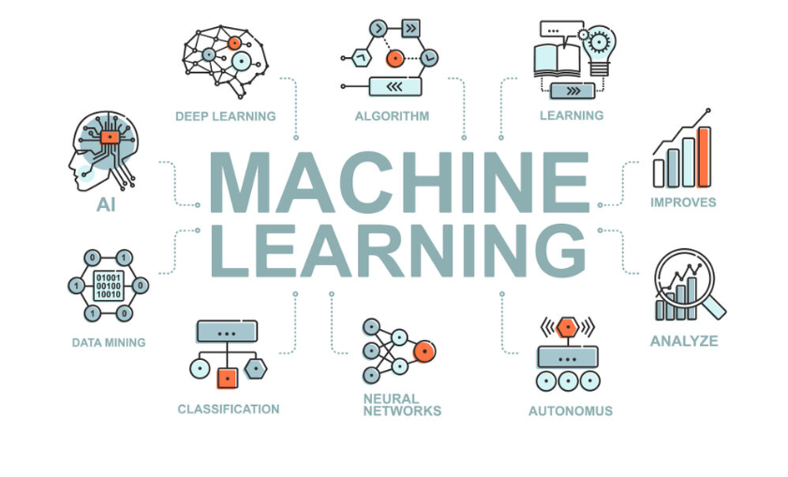
Figure 2.1 Machine Learning

2.2 HOW MACHINE LEARNING WORKS
The standardized machine learning workflow executed during the training program consists of the following sequential stages:
- Data Collection: Gathering high-quality, representative domain data relevant to the target objective.
- Data Preprocessing: Cleaning raw data by addressing missing values, eliminating redundant records, and transforming fields into standardized formats.
- Dataset Splitting: Partitioning dataset samples into training and evaluation subsets (commonly following an 80:20 distribution split).
- Model Selection: Identifying an optimal algorithm tailored to the problem class, such as regression or classification models.
- Model Training: Feeding training data into the selected algorithm to map statistical patterns between inputs and target outputs.
- Evaluation & Testing: Measuring the model's predictive accuracy on unobserved test data using performance metrics like accuracy, precision, or recall.

2.3 APPLICATION OF MACHINE LEARNING
- Recommendation Engines: Powers content and product recommendation algorithms used by modern platforms such as YouTube, Netflix, and Amazon.
- Financial Fraud Detection: Monitors transaction sequences in real time to flag anomalous banking behaviors automatically.
- Medical Diagnostics: Assists healthcare specialists by identifying pathological indicators within medical imagery and clinical datasets.
- Email Spam Filtering: Automatically categorizes and routes incoming communications into primary or secondary folders.
- Predictive Analytics: Analyzes historical market and environmental trends to project real estate valuations, stock fluctuations, and meteorological shifts.

2.4 FEATURES OF MACHINE LEARNING
- Data-Driven Autonomy: Learns mathematical representations directly from data rather than relying on static, hand-written heuristics.
- Iterative Improvement: Continuously enhances prediction accuracy as larger, higher-quality datasets are ingested.
- Scalable Analysis: Processes high-dimensional, complex datasets far beyond human analytical capabilities.
- Pattern Extraction: Detects subtle statistical patterns that are often missed by traditional human inspection.

2.5 ADVANTAGES OF MACHINE LEARNING
- Operational Automation: Minimizes manual intervention by automating complex decision-making processes.
- High Predictive Precision: Improves output reliability as training volumes scale.
- Cross-Domain Adaptability: Integrates seamlessly across diverse technical domains including healthcare, finance, logistics, and agriculture.
- Data-Driven Strategy: Replaces intuition with quantifiable empirical evidence for strategic decision-making.

2.6 LIBRARIES IN MACHINE LEARNING
A substantial portion of the training involved hands-on execution using core Python libraries designed for efficient numerical computing and machine learning workflows.
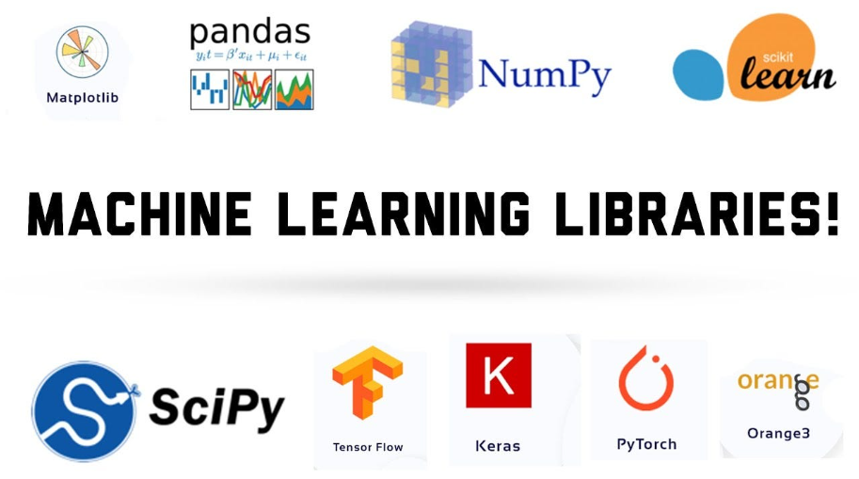
Figure 2.2 Libraries in Machine Learning

2.6.1 NumPy
NumPy (Numerical Python) serves as the core library for scientific computing in Python. It provides high-performance N-dimensional array objects that are significantly faster and more memory-efficient than standard Python lists. Most data science libraries—including Pandas and Scikit-learn—rely directly on NumPy array objects for vectorized operations.
Python
import numpy as np
arr = np.array([10, 20, 30, 40])
print(arr.mean()) # Output: 25.0
print(arr * 2) # Output: [20 40 60 80]

2.6.2 Pandas
Pandas is a foundational data manipulation library designed for handling structured tabular data through two primary data structures: the Series (one-dimensional) and the DataFrame (two-dimensional table with labeled axes). It streamlines common data management operations, such as loading CSV files, indexing, filtering, and performing aggregations.
Python
import pandas as pd
df = pd.read_csv("students.csv")
print(df.head())
print(df[df["marks"] > 80])

2.6.3 Matplotlib
Matplotlib is a core visualization library used to render static visual plots, including line plots, bar charts, scatter plots, and distribution histograms. Graphing data distributions simplifies identifying underlying trends, correlations, and outliers across datasets.
Python
import matplotlib.pyplot as plt
marks = [45, 67, 89, 72, 91]
plt.plot(marks)
plt.title("Marks Trend")
plt.show()
2.6.4 Seaborn
Seaborn is a high-level statistical visualization library built directly on top of Matplotlib. It provides an intuitive interface for rendering visually refined graphs—such as heatmaps, box plots, and pair plots—with minimal code footprint. During training, Seaborn was primarily utilized during Exploratory Data Analysis (EDA) to map feature relationships prior to model development.
Python
import seaborn as sns
sns.boxplot(x="category", y="marks", data=df)
2.6.5 SciPy
SciPy extends NumPy by providing advanced modules for scientific, statistical, and mathematical computations, including optimization, integration, signal processing, and spatial operations. Within machine learning contexts, SciPy powers lower-level statistical routines that extend beyond base NumPy functionality.
Python
from scipy import stats
print(stats.zscore([10, 20, 30, 40, 50]))

2.6.6 Scikit-learn
Scikit-learn is the premier Python framework for classical machine learning applications. It includes built-in implementations of popular machine learning algorithms—such as Linear Regression, Logistic Regression, Decision Trees, K-Nearest Neighbors, and K-Means Clustering—alongside robust utilities for data preprocessing, feature scaling, dataset splitting, and hyperparameter tuning.
Python
from sklearn.model_selection import train_test_split
from sklearn.linear_model import LogisticRegression
X_train, X_test, y_train, y_test = train_test_split(X, y, test_size=0.2)
model = LogisticRegression()
model.fit(X_train, y_train)
print(model.score(X_test, y_test))
2.6.7 OpenCV
OpenCV (Open Source Computer Vision Library) is an industry-standard framework engineered for real-time computer vision and image processing tasks. Its capabilities include reading visual assets, spatial resizing, colorspace conversions, and object detection. In vision-focused ML workflows, OpenCV serves as the primary preprocessing pipeline to prepare pixel matrix inputs before feeding them into deep neural network models.
Python
import cv2
img = cv2.imread("flower.jpg")
img = cv2.resize(img, (128, 128))
cv2.imwrite("flower_resized.jpg", img)

CHAPTER 3: DEEP LEARNING

3.1 DEEP LEARNING
Deep Learning represents a highly specialized and advanced subfield within Machine Learning that centers around the design, implementation, and training of artificial neural networks. These Computational frameworks are conceptualized and loosely modeled after the structural biology and signal processing mechanisms of the human brain's interconnected neuronal networks. While classical, high-level machine learning models frequently rely on human domain expertise to manually select, filter, and extract relevant features from raw data—a process known as feature engineering—deep learning architectures fundamentally bypass this requirement. By leveraging multi-layered hierarchical structures, deep learning models possess the unique capability to autonomously discover, extract, and refine complex feature representations directly from raw, unorganized inputs such as high-resolution images, multi-channel audio files, or unstructured plain text, provided they are trained on sufficiently large volumes of data.
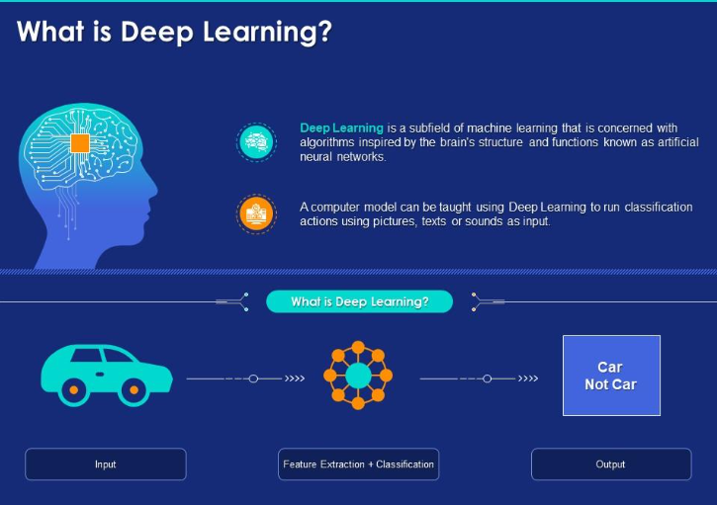
Figure 3.1 Deep Learning

3.2 HOW DEEP LEARNING WORKS?
An artificial neural network operates through a structured computational pipeline composed of layered, interconnected processing units known as artificial neurons or nodes. At its structural core, a typical architecture comprises an input layer designed to ingest raw data features, one or more hidden layers that perform non-linear transformations, and a final output layer that synthesizes these representations into a ultimate classification or regression score. As input data flows forward through the network, each neuron computes a weighted sum of its inputs, adds a bias term, and passes the result through a non-linear activation function (such as ReLU or Softmax) to introduce mathematical complexity. During the initial forward pass, the model generates a baseline prediction which is immediately compared against the ground-truth target using a loss function to calculate numerical error. To optimize performance, the network triggers a backward pass—a process known as backpropagation—which computes the partial derivatives of the loss function with respect to every internal weight using the mathematical chain rule. Optimization algorithms like Stochastic Gradient Descent (SGD) or Adam then make incremental micro-adjustments to these weights. This full cycle of forward propagation, error evaluation, and backward parameter updating is repeated across numerous iterations (epochs) until the network minimizes its loss function and converges on highly accurate predictions.

3.3 APPLICATION OF DEEP LEARNING
- Computer Vision and Image Recognition: Automates object detection, semantic image segmentation, facial verification systems, and handwritten digit classification across digital media and surveillance platforms.
- Natural Language Processing and Speech Recognition: Powers intelligent virtual assistants (such as Siri, Alexa, and Google Assistant) by converting acoustic audio signals into textual representations and interpreting natural human language intent.
- Autonomous Transportation: Drives perception systems in self-driving vehicles, allowing them to perform real-time lane detection, pedestrian tracking, traffic sign identification, and spatial trajectory planning.
- Automated Machine Translation and Conversational AI: Formulates the underlying architecture for modern large language models, dynamic neural translation services, and intelligent customer support chatbots.
- Advanced Medical Imaging and Diagnostics: Assists radiologists and clinical oncologists by inspecting high-resolution MRI scans, CT scans, and X-rays to detect pathological anomalies, cancerous tumors, and tissue micro-calcifications early.

3.4 FEATURES OF DEEP LEARNING
- End-to-End Feature Learning: Eliminates the necessity for manual feature extraction by automatically learning low-level, mid-level, and high-level abstract representations directly from raw data streams.
- Data-Dependent Performance Scaling: Demonstrates non-saturating performance curves where predictive accuracy continuously scales upward as dataset sizes expand into terabyte or petabyte regimes.
- Unstructured Data Mastery: Effortlessly ingests, processes, and extracts spatial, temporal, and semantic patterns from non-tabular datasets such as video streams, raw audio waveforms, and free-form natural text.
- Hardware-Accelerated Compute Capacity: Leverages massively parallel computing architectures—such as Graphics Processing Units (GPUs) and Tensor Processing Units (TPUs)—to execute matrix multiplications and deep tensor operations efficiently.

3.5 ADVANTAGES OF DEEP LEARNING
- Superior Task Accuracy: Consistently outperforms traditional statistical and classical machine learning models in complex domains like computer vision, natural language understanding, and signal processing.
- Minimization of Human Pipeline Engineering: Significantly reduces development overhead and domain-expert intervention by automating the feature selection and engineering phase within the data pipeline.
- High Model Scalability: Demonstrates exceptional capacity to ingest additional training data continuously without reaching the early performance plateaus typical of traditional machine learning algorithms.
- Enabler of Breakthrough Technologies: Facilitates the creation of state-of-the-art technological capabilities that were previously considered computationally intractable, including real-time biometric face authentication, synthetic voice generation, and autonomous navigation.

3.6 LIBRARIES IN DEEP LEARNING

3.6.1 TensorFlow
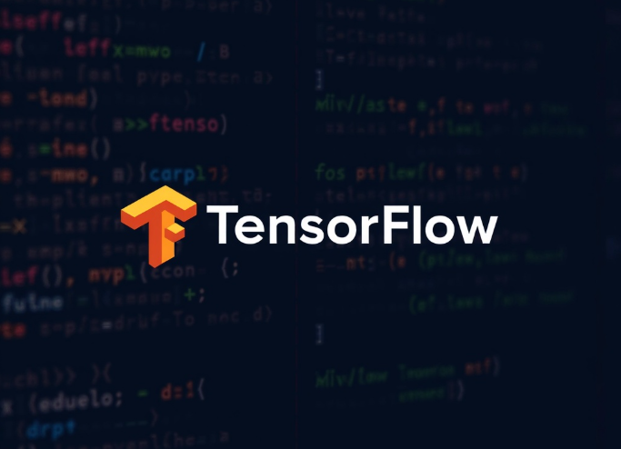
Figure 3.2 Tensor Flow
TensorFlow is an industrial-grade, open-source deep learning framework developed by engineers and researchers at Google. It offers an end-to-end platform for constructing, training, optimizing, and deploying complex neural network models across heterogeneous computing environments. TensorFlow abstracts low-level mathematical linear algebra into high-performance computational graphs that run seamlessly across CPUs, GPUs, and specialized hardware accelerators like TPUs, drastically reducing execution times for large-scale enterprise models.
Python
import tensorflow as tf
model = tf.keras.Sequential([
tf.keras.layers.Dense(64, activation='relu'),
tf.keras.layers.Dense(10, activation='softmax')
])
model.compile(
optimizer='adam',
loss='sparse_categorical_crossentropy'
)

3.6.2 Keras

Figure 3.3 Keras

Keras is a high-level, human-centric Deep Learning API engineered to run on top of low-level computational engines, primarily TensorFlow. Designed with a strong focus on developer productivity, modularity, and rapid prototyping, Keras enables engineers to build complex multi layered neural architectures layer-by-layer using concise, readable syntax. During our training modules, Keras served as the ideal interface for quickly designing, compiling, and evaluating neural network experiments without needing to write extensive boilerplate code.
Python
from tensorflow.keras.models import Sequential
from tensorflow.keras.layers import Conv2D, Flatten, Dense
model = Sequential([
Conv2D(32, (3, 3), activation='relu', input_shape=(28, 28, 1)),
Flatten(),
Dense(10, activation='softmax')
])

3.7 CNN
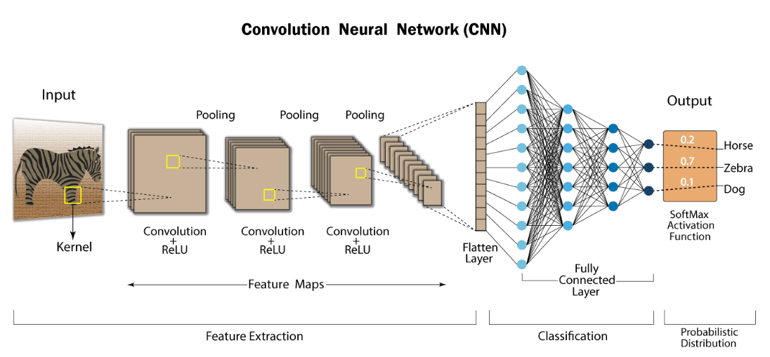
Figure 3.4 CNN
A Convolutional Neural Network (CNN) is a specialized class of deep artificial neural networks meticulously engineered for processing grid-structured spatial data, such as two-dimensional digital images. Rather than flattening an image into a one-dimensional array—which completely destroys critical spatial relationships between adjacent pixels—a CNN utilizes specialized mathematical operations called convolutions. Small, learnable feature detectors known as kernels or filters slide (stride) across the input spatial dimensions, computing dot products to generate two-dimensional feature maps. In the initial layers, these filters learn to register elementary visual primitives such as sharp edges, color gradients, and local orientation lines. As visual feature maps propagate deeper into subsequent convolutional and pooling layers, these low-level features are mathematically combined to construct abstract representations—ranging from textures and geometric shapes to recognizable structural components like human eyes, vehicle wheels, or plant leaves. Due to their shift-invariance and spatial hierarchy preservation, CNNs serve as the core foundational technology for modern computer vision projects, including image classification, real-time object detection, and visual biometric identification.

3.8 RNN
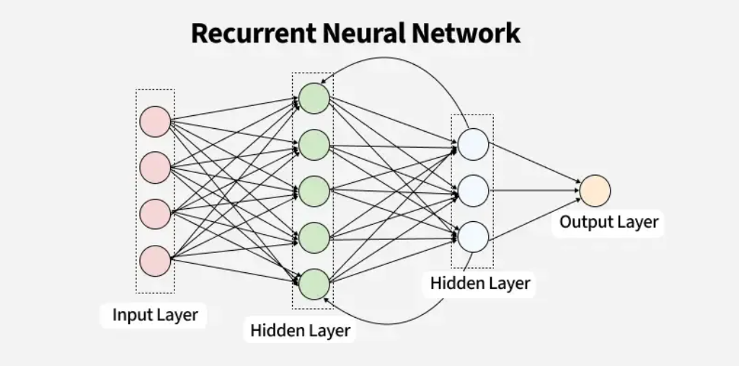
Figure 3.5 RNN
A Recurrent Neural Network (RNN) is a specialized class of neural network architectures designed specifically to model sequential, time-series, or ordered data where temporal context and sequential ordering are critical to prediction accuracy. Unlike standard feedforward neural networks that assume all input samples are independent of one another, an RNN incorporates internal memory loops or hidden state vectors. This design enables information to persist across sequential processing steps: the output computed at step t-1 is looped back into the network along with the new input element at step t. This cyclic feedback loop allows the network to maintain a contextual memory of historical inputs while processing current inputs, making RNNs exceptional at evaluating contextual dependencies across sentences, continuous speech audio waves, and temporal stock market sequences. Consequently, RNNs form the structural baseline for sequence-to-sequence engineering tasks such as automated multi-language translation, generative text prediction, voice synthesis, and sentiment analysis.

CHAPTER 4: GAMING

4.1 ABOUT GAMING
Alongside data-centric disciplines such as Machine Learning and Deep Learning, the training curriculum incorporated interactive game development using Python. This segment provided an engaging, hands-on contrast to purely statistical modeling by shifting focus toward real-time visual output, interactive input handling, and dynamic user interfaces rather than numerical datasets and predictive values. Although high-performance production studios often associate low-level systems of languages like C++ with AAA engine development, Python serves as an outstanding foundational language for mastering core game engineering principles. Its minimal syntax footprint allows developers to rapidly learn essential engine architecture components—including infinite game loops, hardware event handling, spatial collision detection, frame rate control, and 2D/3D graphics rendering—without becoming bogged down by complex memory management or tedious low-level boilerplate code.

4.2 POPULAR LIBRARIES FOR GAME DEVELOPMENT IN PYTHON

4.2.1 Pygame
Pygame is the most established, widely adopted cross-platform Python library designed explicitly for constructing two-dimensional games and multimedia applications. Built directly on top of the Simple Direct Media Layer (SDL) development library, Pygame provides high-level Python wrappers for low-level system hardware functions. It offers comprehensive, out-of-the-box functionalities for rendering primitive shapes and bitmap images, managing spatial audio playback, executing bounding-box collision detection algorithms, and capturing real-time keyboard, mouse, or game controller input events. These integrated features enable developers to construct fully functional, interactive 2D games with a remarkably concise and readable codebase.
import pygame
pygame.init()
screen = pygame.display.set_mode((400, 400))
running = True
while running:
for event in pygame.event.get():
if event.type == pygame.QUIT:
running = False
pygame.display.update()

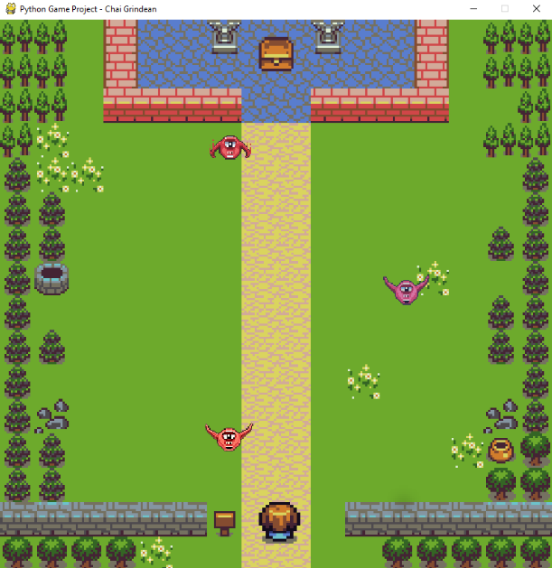
Fig 4.1: Treasure Hunt

4.2.2 Arcade
Arcade is a modern, object-oriented 2D game development framework for Python engineered with a strong emphasis on clean, modern design patterns and developer productivity. Built upon OpenGL, Arcade leverages contemporary hardware-accelerated graphics capabilities to deliver higher frame rates and smoother rendering performance compared to older software-rendered libraries. It features an intuitive, highly Pythonic API that simplifies sprite sheet management, tile-map integration, physics engine interactions, and programmatic scene management. While exceptionally accessible for educational instruction and beginner game programmers, Arcade possesses sufficient architectural depth to build rich, complex multi-layered 2D games.

Fig 4.2: jumper game
Python
import arcade
class MyGame(arcade.Window):
def __init__(self):
super().__init__(400, 400, "Arcade Demo")
MyGame().run()

4.2.3 Turtle
Turtle Graphics is an integrated standard module within the core Python library, serving as a classic, beginner-friendly entry point into computer graphics, spatial geometry, and event-driven programming. Based on the historic Logo programming language paradigm, Turtle operates on a virtual vector graphics canvas controlled by an onscreen pen (the "turtle"). Programmers issue sequential directional commands—such as .forward(), .left(), and .right()—to dynamically draw geometric lines and vector shapes. Although Turtle lacks the hardware acceleration required to power full-scale production games, it provides an invaluable framework for developing a solid understanding of Cartesian coordinate systems, loop structures, trigonometric rotation, and elementary animation logic.
Python
import turtle
t = turtle.Turtle()
for i in range(4):
t.forward(100)
t.right(90)
turtle.done()

4.2.4 Ursina
Ursina Engine is an open-source Python engine engineered specifically to streamline 3D game development and interactive visualization using minimal code complexity. Built on top of the industrial Panda3D game engine and powered by high-performance graphics backends, Ursina abstracts away the heavy setup overhead usually associated with 3D graphics development. It exposes a clean entity-component system that simplifies spatial placement, 3D mesh rendering, material texture mapping, camera transformation, dynamic lighting, and user input binding. During our training, Ursina served as a practical introductory platform for exploring spatial 3D environments, camera positioning vectors, spatial transforms, and lighting pipelines without requiring the extensive learning curve of traditional commercial 3D engines like Unity or Unreal Engine.
Python
from ursina import *
app = Ursina()
cube = Entity(model='cube', color=color.orange)
app.run()

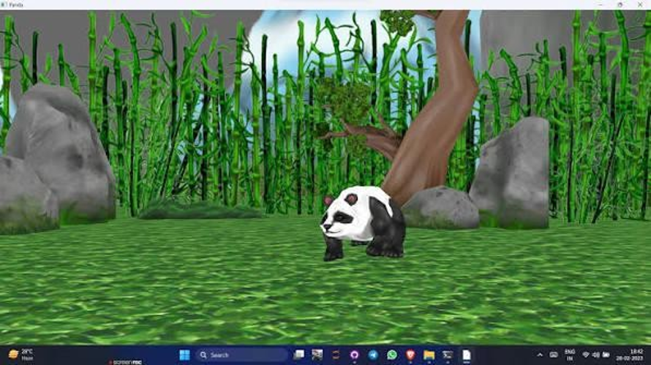
Fig 4.3: Ursina

CHAPTER 5: INTRODUCTION TO AI

5.1 ARTIFICIAL INTELLIGENCE
Artificial Intelligence (AI) is a foundational, multidisciplinary domain within computer science dedicated to engineering intelligent systems capable of performing computational and cognitive tasks that historically demand human intelligence. These complex cognitive functions include natural language understanding, visual scene perception, abstract reasoning, strategic decision-making, pattern recognition, and autonomous problem-solving. Rather than serving as a single isolated technology, Artificial Intelligence operates as an overarching academic and technical framework. The specialized domains explored earlier in this report—including classical Machine Learning, deep artificial neural networks, and interactive graphics engines—represent focused sub-fields operating directly underneath this broad AI paradigm.
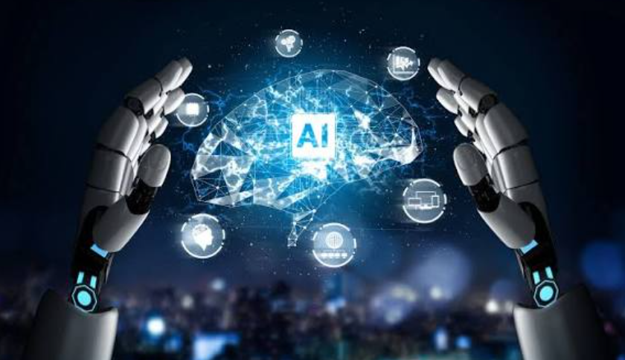
Figure 5.1 Artificial Intelligence

5.2 WORKING OF ARTIFICIAL INTELLIGENCE
At its structural core, an artificial intelligence framework functions through an iterative pipeline centered on data ingestion, algorithmic execution, state synthesis, and action generation. The computational cycle begins when raw, high-dimensional data is fed into the system. This data is processed through mathematical logic engines, parametric statistical models, or multi-layered deep neural networks engineered to extract latent representations and map relationships. Depending on the underlying architecture, decision-making can range from deterministic, rule-based systems (expert systems employing explicit branching logic) to probabilistic statistical models and self-optimizing neural networks. Crucially, advanced AI architectures incorporate continuous feedback loops. By evaluating output accuracy against performance metrics or environmental rewards, the system incrementally adjusts its internal parameters, weights, or heuristic policies over time. This continuous mathematical refinement gives the system its ability to learn dynamically, adapt to changing inputs, and optimize its predictive precision over prolonged execution periods.

5.3 APPLICATIONS OF ARTIFICIAL INTELLIGENCE
- Voice Assistants and Conversational Interfaces: Powers ubiquitous intelligent assistants (such as Apple Siri, Amazon Alexa, and Google Assistant) using integrated automatic speech recognition (ASR) and natural language understanding (NLU) pipelines.
- Information Retrieval and Search Personalization: Drives modern search engines, utilizing semantic ranking models and user behavior analytics to deliver contextual, intent-driven search results.
- Automated Customer Service Systems: Operates conversational chatbots and virtual triage agents across digital platforms to resolve customer inquiries autonomously.
- Algorithmic Recommendation Engines: Analyzes massive user behavior datasets on e-commerce and streaming platforms (such as Amazon, Netflix, and Spotify) to deliver real-time personalized content feeds.
- Autonomous Mobility and Intelligent Infrastructure: Powers perception, localization, path planning, and obstacle avoidance algorithms in self-driving vehicles, alongside automated municipal traffic routing networks.

5.4 TYPES OF ARTIFICIAL INTELLIGENCE
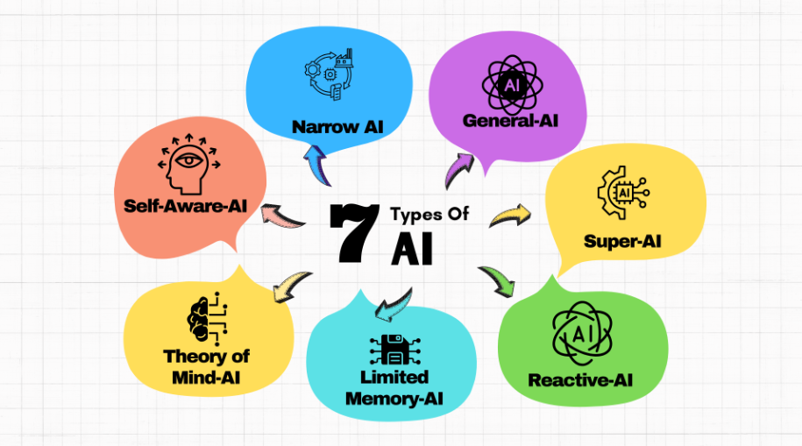
Figure 5.2 Types of AI

5.4.1 Narrow AI
Narrow AI—frequently classified as Weak AI—describes purpose-built artificial intelligence systems engineered, optimized, and trained exclusively to execute a single, highly specific operational task. While a Narrow AI model can achieve exceptional, superhuman performance within its constrained domain, it lacks the general cognitive capacity to transfer its learned representations or adapt to tasks outside its predefined boundary. Virtually every real-world AI deployment operating in industry today—including automated spam detection algorithms, medical image classifiers, facial biometric authentication systems, and strategic chess engines—falls firmly within the scope of Narrow AI.

5.4.2 General AI
General AI—often referred to as Artificial General Intelligence (AGI) or Strong AI—represents a theoretical tier of machine intelligence capable of understanding, learning, contextualizing, and applying intellectual capabilities across any cognitive domain, fully mirroring the adaptive versatility of human intellect. Unlike Narrow AI models limited to static domain boundaries, an AGI system would possess self-directed reasoning, transfer learning, meta-cognition, and cross-domain operational flexibility. As of today, true Artificial General Intelligence remains an unrealized concept and serves as a major long-term research focus across computer science and cognitive research institutions.

5.4.3 Super AI
Super AI, or Artificial Superintelligence (ASI), represents a hypothetical stage of AI evolution where machine intellect surpasses collective human intelligence across every measurable dimension—including abstract logic, scientific innovation, artistic creativity, emotional reasoning, and strategic decision-making. Operating beyond human cognitive bounds, Super AI exists primarily as a conceptual framework within theoretical computer science, ethics, and futurology, with no practical physical realization existing today.

5.5 LLM
A Large Language Model (LLM) is an advanced deep learning architecture trained on vast textual datasets containing billions—or trillions—of linguistic tokens to interpret, synthesize, and generate natural language. Built predominantly on Transformer network architectures featuring multi-head self-attention mechanisms, LLMs like the GPT series model complex statistical dependencies between words across massive contextual windows. At its core computational layer, an LLM functions by predicting the most statistically probable next token in a sequence given the preceding context. Having ingested vast cross-disciplinary knowledge bases during training, these models exhibit emergent capabilities—enabling them to handle natural language translation, technical summarization, complex question answering, logical reasoning, and source code generation.

5.6 AI AGENT
An AI Agent is an autonomous or semi-autonomous software entity designed to perceive environmental state data, process contextual information, formulate strategic decisions, and execute targeted actions to fulfill specific operational goals with minimal human intervention. Unlike a standard, passive machine learning model that strictly maps a single static input to a static output, an AI Agent operates actively within an execution environment. It possesses the capability to decompose complex instructions into sequential action pipelines, interface dynamically with external APIs and tools (such as executing web queries, querying databases, or running code interpreters), evaluate intermediate results against its overarching goal, and adjust its plan based on real-world feedback.

5.7 AGENTIC AI
Agentic AI extends the concept of an individual AI agent into a sophisticated, multi-agent computational paradigm capable of managing complex, highly ambiguous, end-to-end workflows with high autonomy. Rather than operating as a simple conversational system or relying on continuous step-by-step human prompts, an Agentic AI architecture operates as an autonomous manager. Given an abstract, high-level directive, the system autonomously conducts sub-task decomposition, establishes temporal execution hierarchies, delegates tasks across specialized internal sub-agents, interfaces with digital tools, and self-evaluates intermediate outcomes. If an intermediate sub-task fails or returns unexpected data, the agentic framework self-corrects, adjusts its planning tree, and iterates until the objective is reached. Agentic AI represents the next major paradigm shift in artificial intelligence, transitioning models from passive content-generation engines into active, goal-driven computational partners.

CHAPTER 6: PROJECTS IN PYTHON

6.1 HANGMAN GAME

Overview
As a practical application of fundamental Python programming, control flow logic, dynamic state tracking, and interface design covered during the training, an enhanced interactive project titled Hangman: Verb Edition was constructed. In this specialized vocabulary game, players guess hidden verbs across multiple custom difficulty tiers while managing a finite reserve of lives, utilizing optional hints, and competing for speed and accuracy scores.
Figure 6.1: Hangman Verb Edition landing screen featuring player name initialization and game mode highlights.

Approach
- User Profile & Name Input: The application prompts the player to register their name upon launch, initializing a personalized session state that tracks continuous win/loss stats and aggregate point totals.
- Tiered Difficulty System: The game features five distinct difficulty levels with custom rules:
  - Rookie – Allows up to 8 wrong guesses.
  - Explorer – Allows up to 7 wrong guesses.
  - Challenger – Allows up to 6 wrong guesses.
  - Expert – Allows up to 6 wrong guesses with higher word complexity.
  - Master – Allows up to 5 wrong guesses for maximum challenge.

Figure 6.2: Level selection interface displaying difficulty tiers, star ratings, and allowable wrong guess limits.
- Dynamic Gameplay Mechanics & ASCII Graphics: The interface dynamically updates an ASCII-rendered gallows along with a progress bar tracking remaining lives (X/Y wrong). It displays letter counts, word categories, and active letter choice menus (Q W E R T...).
- Hint System & Scoring Engine: Players can trigger an optional hint ([H] Hint) at the cost of 1 life to reveal key letter patterns. Scoring is calculated dynamically based on speed and accuracy upon round completion.

Figure 6.3: Active gameplay interface showing level details, letter blanks, ASCII gallows, and life indicators.
A simplified representation of the core state-updating and letter-guessing logic is illustrated below:
Python
def guess_letter(word, guessed, letter):
if letter in word:
for i, ch in enumerate(word):
if ch == letter:
guessed[i] = letter
return True # Correct guess
return False # Wrong guess

Libraries Used
- os & sys: Employed for terminal screen management, interface formatting, and real-time buffer updates.
- random: Utilized for pseudo-random selection of target verbs from internal dictionary arrays.
- time: Integrated to measure round duration and calculate speed-based scoring multipliers.

Figure 6.4 End-of-round state displays showing a Game Over failure screen

6.5: End-of-round state displays showing a Game Over a successful Victory screen with points earned.

Result
The application successfully executed all state transitions, handling game-over conditions when lives reached zero (revealing the target word, e.g., "LAUGH") and granting point rewards upon victory (e.g., +318 points for uncovering "MOVE").

6.2 CLASSIFICATION OF IRIS FLOWER IN MACHINE LEARNING

Overview
This project involved constructing an interactive image-based Iris flower classification application using Machine Learning and Deep Learning vision principles. The system classifies unknown sample images into one of three canonical Iris species—Iris setosa, Iris versicolor, or Iris virginica—and outputs a real-time prediction confidence percentage via a clean graphical user interface (GUI).
Figure 6.6: Representative sample images of the three target species: Iris Setosa, Iris Versicolor, and Iris Virginica.

Approach
- Data Processing & Model Training: Botanical feature datasets and image data were preprocessed using normalization and scaling. Machine learning algorithms (such as Decision Trees / Logistic Regression) and convolutional vision layers were trained to recognize distinct petal and sepal visual features.
- GUI Development: A desktop user interface was designed with an image upload dialog box (Upload Image), enabling non-technical users to input external flower images seamlessly.
- Real-Time Confidence Inference: Upon uploading an image, the trained classifier processes the pixel data, executes model evaluation, and outputs the top predicted species along with a fractional confidence probability.
Python
from sklearn.datasets import load_iris
from sklearn.model_selection import train_test_split
from sklearn.tree import DecisionTreeClassifier
from sklearn.metrics import accuracy_score
data = load_iris()
X_train, X_test, y_train, y_test = train_test_split(
data.data, data.target, test_size=0.2, random_state=42
)
model = DecisionTreeClassifier()
model.fit(X_train, y_train)
predictions = model.predict(X_test)
print("Accuracy:", accuracy_score(y_test, predictions))
Figure 6.7: Graphical User Interface demonstrating real-time model inference ("Versicolor - Confidence: 68.43%").

Libraries Used
- Pandas & NumPy: Utilized for structural array processing, matrix calculations, and dataset formatting.
- Scikit-Learn: Employed for data splitting, training multi-class models, and computing accuracy evaluation metrics.
- Tkinter / PyQt & OpenCV / PIL: Used to render the application window, display visual image previews, and handle file system interactions.

Result
The completed machine learning system demonstrated strong practical classification capabilities, accurately recognizing uploaded test samples (e.g., predicting Versicolor with a 68.43% confidence metric) and delivering a seamless interactive user experience.

6.3 HANDWRITTEN DIGIT CLASSIFICATION IN DEEP LEARNING

Overview
This project focused on developing a deep learning vision pipeline designed to recognize and classify handwritten numerical digits (0 through 9) using the benchmark MNIST dataset. Comprising 70,000 standardized 28 x 28 pixel grayscale digit images collected from diverse handwriting samples, the MNIST dataset serves as an industry standard for training, testing, and benchmarking neural network vision models.
Figure 6.8 code for digit recognition

Approach
- Dataset Ingestion: The MNIST dataset—partitioned into 60,000 training examples and 10,000 test examples—was loaded directly via Keras dataset modules.
- Feature Normalization: Raw pixel intensity values ranging from [0, 255] were rescaled to floating-point values between [0.0, 1.0], optimizing gradient descent stability and accelerating model convergence.
- CNN Architecture Design: A Convolutional Neural Network (CNN) was constructed using Tensor Flow and Keras, incorporating spatial convolution layers for localized feature extraction, max-pooling layers for spatial down sampling, and dense multi-layer perceptron layers for final softmax probability routing.
- Model Fitting & Tracking: The network was compiled and trained over multiple training epochs, tracking training/validation loss and predictive accuracy metrics across iterations.
- Out-of-Sample Testing: Model performance was verified on the formal MNIST test partition as well as on custom, real-time hand-drawn digit samples to assess real-world generalization.
Python
from tensorflow.keras.datasets import mnist
from tensorflow.keras.models import Sequential
from tensorflow.keras.layers import Conv2D, MaxPooling2D, Flatten, Dense
(x_train, y_train), (x_test, y_test) = mnist.load_data()
x_train, x_test = x_train / 255.0, x_test / 255.0
model = Sequential([
Conv2D(32, (3, 3), activation='relu', input_shape=(28, 28, 1)),
MaxPooling2D(2, 2),
Flatten(),
Dense(64, activation='relu'),
Dense(10, activation='softmax')
])
model.compile(
optimizer='adam',
loss='sparse_categorical_crossentropy',
metrics=['accuracy'])
model.fit(x_train, y_train, epochs=5)

Libraries Used
- TensorFlow & Keras: Employed for neural network architecture definition, layer compilation, backpropagation training, and model inference.
- NumPy: Used for multidimensional array manipulation and tensor transformations.
- Matplotlib: Applied to chart training loss curves, accuracy trends, and sample image classifications.

Figure 6.9 recognition(a)
Figure 6.10 recognition(b)

Result
The Convolutional Neural Network achieved high classification accuracy on the isolated test set while successfully generalizing freshly drawn digit inputs. This confirmed that the model had learned robust structural feature representations rather than simply memorizing training instances, demonstrating the practical workflow of deep learning image classification pipelines.

CHAPTER 7: MAJOR PROJECT – PROBOT AI: AI-BASED DESKTOP RESEARCH LIBRARY AND INTELLIGENT KNOWLEDGE DISCOVERY SYSTEM

7.1 INTRODUCTION & PROJECT OVERVIEW

7.1.1 Background & Problem Statement
In contemporary academic research, software engineering, and technical study, efficient knowledge management and rapid information retrieval play a vital role in learning. However, traditional online research workflows rely heavily on manual search engine queries, copy-pasting article text into unorganized document files, and saving dozens of browser bookmarks. This manual workflow introduces severe practical challenges for students and researchers:
1. Information Fragmentation: Important study notes and references get scattered across multiple browser tabs, PDF files, and text documents, making it difficult to locate specific information later.
2. Cloud Privacy Risks & Constant Internet Dependence: Existing AI search tools send user queries and uploaded document contents to third-party cloud servers, creating privacy risks and making research impossible without active internet connectivity.
3. Information Overload & Research Fatigue: Reading lengthy articles to extract key definitions, main concepts, and revision questions consumes significant time and causes study fatigue.
4. Loss of Reference Context: Traditional search engines match keywords rather than actual meaning, making it difficult to find relevant answers when queries use different wording or synonyms.

7.1.2 Proposed Solution: ProBot AI Desktop Research Library
To solve these problems, ProBot AI was designed and developed as an end-to-end, offline-first desktop research library and intelligent knowledge discovery platform. ProBot AI provides a complete personal research workspace where users can search Wikipedia articles, save research papers, extract text from local PDF documents, generate structured study notes, build visual concept maps, auto-create revision questions, and chat with a local AI assistant.
- Key highlights of the ProBot AI solution include:
- • 100% Offline-First Capability: All saved articles, vector embeddings, and database records operate locally on the user's computer without requiring an internet connection.
- • Smart Semantic Search: Uses artificial intelligence embeddings to search by actual meaning rather than exact word matching.
- • Automated Study Tools: Automatically generates structured study notes, ASCII visual concept maps, and exam revision flashcards from any saved article.
• Privacy-Preserving Local AI Chat: Connects to a local Ollama AI model (Phi-3 Mini / Llama 3) to answer user questions grounded strictly in saved article text.
• Multi-Format Document Exporters: Allows exporting complete study packs into professionally styled PDF documents and Microsoft Word (.docx) files complete with automatic citations.

7.1.3 Core System Architecture & 5-Stage Pipeline
The overall architecture of ProBot AI operates through a structured 5-stage processing pipeline that converts raw web articles and PDF documents into organized study materials:
- [ ========================================================================= ]

[ INSERT FIGURE 7.1: PROBOT AI SYSTEM ARCHITECTURE & LANDING OVERVIEW HERE ]
- [ Replace this placeholder block with your screenshot of ProBot AI System Architecture / Main Landing Screen ]
- [ ========================================================================= ]
Figure 7.1: ProBot AI System Architecture Diagram displaying the 5-stage data processing pipeline from document ingestion to local AI response rendering.
The five core architectural stages include:
1. Ingestion & Document Reader Stage (downloader.py, pdf_reader.py): Downloads Wikipedia articles, extracts main article body text, saves thumbnail images, and extracts raw text from local PDF documents.
2. Dense Vector Semantic Search Stage (semantic_search.py): Uses SentenceTransformers (all-MiniLM-L6-v2) to convert text sentences into 384-dimensional numerical vectors and performs fast cosine similarity matching.
- 3. NLP & Note Synthesis Stage (notes_generator.py, intent_engine.py): Uses SpaCy (en_core_web_sm) for entity recognition, term frequency scoring, structural note extraction, ASCII concept mapping, and intent classification.
- 4. Local LLM RAG Reasoning Core (ai_assistant.py): Connects to the local Ollama daemon to stream context-grounded AI assistant responses without cloud API keys.
- 5. User Interface & Persistence Stage (gui.py, database.py): Renders an interactive CustomTkinter desktop interface with SQLite relational database persistence (WAL mode).

7.1.4 Target Research Modes
ProBot AI dynamically customizes its processing pipeline based on the active research mode selected by the user:
- • Offline Knowledge Base Mode: Allows searching and reviewing locally saved SQLite articles when no internet connection is available.
- • Deep Research Pack Mode: Aggregates multi-source web search results (Wikipedia, DuckDuckGo, web pages) into unified study packs.
- • Study Notes & Concept Map Mode: Automatically creates bullet-point summaries, key definitions, ASCII visual concept graphs, and revision questions.
• Interactive Local AI Assistant Mode: Enables real-time streaming conversational chat grounded strictly in retrieved article paragraphs.

7.2 SMART SEARCH ENGINE & NLP LANGUAGE PROCESSING

7.2.1 Semantic Vector Search (all-MiniLM-L6-v2)
Traditional keyword search engines search for exact matching words. For example, searching for 'car' might fail to find an article about 'automobiles' if the exact word 'car' is absent. ProBot AI solves this by using semantic vector search powered by the SentenceTransformers model (all-MiniLM-L6-v2).
The model converts sentences into 384-dimensional numerical vectors (dense embeddings) where sentences with similar meanings are positioned close together in vector space. This allows ProBot AI to find relevant information even when different wording, synonyms, or paraphrasing are used.

7.2.2 Cosine Similarity Matching
To find the most relevant article paragraphs for a user query, ProBot AI calculates the Cosine Similarity score between the user query vector (v_Q) and each candidate text chunk vector (v_S):
CosineSimilarity(v_Q, v_S) = (v_Q · v_S) / (||v_Q|| * ||v_S||)
In simple terms, Cosine Similarity measures the angle between two direction vectors in multi-dimensional space. A similarity score of 1.0 means the query and paragraph have identical meaning, while scores near 0 mean they are unrelated. Passages exceeding a threshold score (score >= 0.12) are selected for study notes and AI context generation.

7.2.3 SpaCy Key Topic & Entity Extraction (en_core_web_sm)
ProBot AI integrates the SpaCy Natural Language Processing library (en_core_web_sm) to automatically recognize key entities (such as names of people, organizations, locations, and technical topics) and filter out common stop words (e.g. 'the', 'is', 'at').
The implementation code for topic extraction in intent_engine.py is shown below:
Python
# SpaCy Topic & Entity Extraction Implementation
def extract_topic(self, question):
doc = self.load_nlp()(question)
if len(doc.ents) > 0:
return doc.ents[0].text
stop_words = {'what', 'who', 'when', 'where', 'why', 'how', 'is', 'are'}
words = [token.text for token in doc if token.text.lower() not in stop_words and token.is_alpha]
return ' '.join(words)

7.2.4 Article Chunking & Fast Indexing
Large articles contain thousands of words. To ensure fast search speeds and precise AI answers, ProBot AI uses chunker.py to divide long articles into overlapping 500-token passages with a 50-token overlap. The overlap ensures that sentences spanning across chunk boundaries are not cut off, maintaining full contextual continuity.

7.3 AUTOMATED STUDY NOTES, CONCEPT MAPS & INTENT ENGINES

7.3.1 NotesGenerator & Automatic Summary Creation
- The NotesGenerator class (notes_generator.py) automates the process of creating study notes from long articles. It performs Term Frequency (TF) scoring to identify high-importance keywords, extracts key definition patterns (such as 'X is defined as Y'), and formats the main points into clean bullet-point summaries.

7.3.2 ASCII Concept Map Generation & Visual Graphs
To help visual learners understand complex topics, NotesGenerator extracts structural relationships between main topics and sub-topics, formatting them into clean ASCII visual concept maps:
[ ========================================================================= ]

[ INSERT FIGURE 7.2: ASCII CONCEPT MAP & STUDY NOTES GENERATOR VIEW HERE ]
- [ Replace this placeholder block with your screenshot of the Concept Map & Study Notes View ]
[ ========================================================================= ]
Figure 7.2: ASCII Concept Map & Study Notes View displaying automatically generated hierarchical topic graphs and key summary points.
An example of an automatically generated ASCII Concept Map structure is shown below:
CONCEPT: Quantum Computing
├── Sub-Topic 1: Superposition & Qubits
│ ├── State Vector Representation
│ └── Bloch Sphere Geometry
├── Sub-Topic 2: Quantum Entanglement
│ └── Bell State Measurement
└── Sub-Topic 3: Quantum Algorithms
├── Shor's Factoring Algorithm
└── Grover's Search Acceleration

7.3.3 Automatic Revision Question & Exam Flashcard Generator
To help students test their knowledge before exams, NotesGenerator parses definition statements and entity pairs from saved articles to automatically generate multiple-choice and short-answer revision flashcards. This encourages active recall study methods.

7.3.4 Natural Language Query Intent Routing
When a user types a query in ProBot AI, intent_engine.py analyzes the natural language intent to determine the exact action required:
• General Inquiry: Routed to local vector search for article lookup.
• Article Specific Question: Routed to the local Ollama LLM RAG assistant for grounded Q&A.
• Request for Study Notes: Routed to NotesGenerator for bullet-point and concept map creation.

7.4 OLLAMA LOCAL AI ASSISTANT & PRIVACY-PRESERVING CHAT

7.4.1 Local Privacy-Preserving AI Core (Ollama Phi-3 Mini / Llama 3)
  - ProBot AI includes a built-in AI assistant driven by Ollama (ai_assistant.py). Ollama runs Large Language Models locally on the user's personal computer. This provides major advantages:
  - 1. Complete Data Privacy: User questions, study notes, and documents never leave the computer.
- 2. Zero API Cost: No subscriptions, token limits, or third-party cloud API costs.
3. Full Offline Support: Operates seamlessly even when disconnected from the internet.
The system includes an automatic fallback hierarchy (llama3 -> mistral -> phi3:mini) to ensure compatibility across different hardware specifications.

7.4.2 Context-Grounded Prompting (Retrieval-Augmented Generation - RAG)
To prevent AI hallucinations (making up incorrect facts), ProBot AI uses Retrieval-Augmented Generation (RAG). When a user asks a question, ProBot AI first retrieves the Top-12 most relevant paragraphs from the local SQLite database. It then inserts those paragraphs directly into the LLM prompt envelope:
Python
# Local RAG Prompt Construction Schema
payload_metadata = {
"detected_topic": "Quantum Computing",
"retrieved_chunks": [
"Qubits leverage superposition to exist in states 0 and 1 simultaneously...",
"Quantum entanglement enables instant state correlations across spatial distances..."
],
"user_query": "Explain how superposition accelerates quantum search algorithms.",
"model_target": "phi3:mini"
}

7.4.3 Interactive AI Assistant Chatbot
- ProBot AI features an interactive desktop chat panel where students can ask questions about any saved article.
- [ ========================================================================= ]

[ INSERT FIGURE 7.3: LOCAL OLLAMA RAG CHATBOT INTERFACE HERE ]
- [ Replace this placeholder block with your screenshot of the Local Ollama AI Chatbot Panel ]
[ ========================================================================= ]
Figure 7.3: Local Ollama AI Assistant Chatbot Interface demonstrating streaming context-grounded Q&A based on saved research articles.
Pre-configured quick prompt buttons allow instant consultation:
• 'Explain key concepts in simple terms'
• 'Generate 5 exam revision questions from this article'
- • 'Summarize main findings and research methodology'

7.5 CUSTOMTKINTER DASHBOARD, ANALYTICS, & KNOWLEDGE LEDGER

7.5.1 Desktop User Interface & Dark/Light Themes (gui.py)
The application graphical user interface is built using CustomTkinter (gui.py), providing a sleek, modern desktop appearance with full dark and light mode support.
[ ========================================================================= ]
Subsystem | Technology / Library | Architectural Function
Frontend Framework | CustomTkinter v5.2, Tkinter | Desktop window rendering, sidebar navigation, dark/light themes, streaming AI chat UI
Vector Embedding Engine | Sentence-Transformers (all-MiniLM-L6-v2) | 384-dimensional dense vector embeddings and fast cosine similarity search
NLP Pipeline | SpaCy (en_core_web_sm) | Named Entity Recognition, stopword filtering, and key topic extraction
Local LLM Engine | Ollama Daemon (phi3:mini / llama3) | Privacy-preserving local RAG AI assistant without third-party API keys
Database Ledger | SQLite3 (WAL Mode) | Relational local persistence for articles, research chunks, and embeddings
Web Harvesting | DuckDuckGo (ddgs) & BeautifulSoup4 | Multi-source web research aggregation and HTML text extraction

[ INSERT FIGURE 7.4: CUSTOMTKINTER MAIN DESKTOP DASHBOARD HERE ]
[ Replace this placeholder block with your screenshot of the CustomTkinter Main Desktop Dashboard ]
- [ ========================================================================= ]
- Figure 7.4: CustomTkinter Main Desktop Dashboard featuring dark/light appearance toggle, sidebar tab navigation, search view, and article reader panel.
- Key UI features include:
- • Navigation Sidebar: Easy access to Search, Saved Library, Study Notes, AI Chat, and Settings.

CONCLUSION
The six-week training program has been an enriching and transformative journey, providing me with comprehensive exposure to some of the most cutting-edge domains in modern computer science. Through structured hands-on sessions and practical implementation, I developed a solid foundation in Python programming, which served as the core backbone for mastering advanced concepts across Machine Learning, Deep Learning, Game Development, and Artificial Intelligence.
Python’s high-level, interpretable architecture, readable syntax, and rich ecosystem of specialized libraries—such as NumPy, Pandas, OpenCV, TensorFlow, and Pygame—accelerated my ability to design, build, and deploy complex software solutions. My exploration expanded into modern Artificial Intelligence architectures, ranging from foundational Machine Learning algorithms to deep Neural Networks, Large Language Models (LLMs), and autonomous Agentic AI systems.

The highlight of this training was the successful conceptualization and development of my major project, ProBot AI: AI-Based Desktop Research Library and Intelligent Knowledge Discovery System. This project allowed me to synthesize my technical skills by integrating real-time object detection via SentenceTransformers, predictive analytics with SpaCy NLP, interactive generative capabilities using the Ollama Phi-3 Mini API, and dynamic ASCII concept mapping.

This multidisciplinary experience has significantly enhanced my technical engineering skills, logical reasoning, and end-to-end system development capabilities. Supported by guided mentorship and real-world project development, I have gained the confidence to tackle complex technical challenges, architect intelligent applications, and adapt to the fast-paced evolution of AI and software engineering. Overall, this training has laid a robust foundation for my technical career, inspiring me to pursue further specialization and contribute meaningfully to the future of technology.

REFERENCES
- Python Software Foundation. (2024). Python Language Reference, Version 3.x. Available at: https://www.python.org/
- McKinney, W. (2010). Data Structures for Statistical Computing in Python. Proceedings of the 9th Python in Science Conference (SciPy 2010), pp. 56–61. (Pandas Library)
- Harris, C. R., et al. (2020). Array programming with NumPy. Nature, 585(7825), pp. 357–362.
- Pedregosa, F., et al. (2011). Scikit-learn: Machine Learning in Python. Journal of Machine Learning Research, 12, pp. 2825–2830.
- The highlight of this training was the successful conceptualization, engineering, and implementation of the major project, ProBot AI: AI-Based Desktop Research Library and Intelligent Knowledge Discovery System. This project allowed me to synthesize my technical skills by integrating dense vector semantic search via SentenceTransformers (all-MiniLM-L6-v2), automated study note and ASCII concept map synthesis using SpaCy NLP, interactive generative capabilities using local Ollama LLMs (Phi-3 Mini / Llama 3), and a responsive desktop user interface using CustomTkinter.
- Abadi, M., et al. (2016). TensorFlow: A System for Large-Scale Machine Learning. 12th USENIX Symposium on Operating Systems Design and Implementation (OSDI 16), pp. 265–283.
- Chollet, F., et al. (2015). Keras: Deep Learning for Humans. GitHub Repository. Available at: https://github.com/fchollet/keras
- 8. Honnibal, M., & Montani, I. (2017). spaCy 2: Natural language understanding with Bloom embeddings, convolutional neural networks and incremental parsing. (SpaCy NLP Framework)
- The highlight of this training was the successful conceptualization, engineering, and implementation of the major project, ProBot AI: AI-Based Desktop Research Library and Intelligent Knowledge Discovery System. This project allowed me to synthesize my technical skills by integrating dense vector semantic search via SentenceTransformers (all-MiniLM-L6-v2), automated study note and ASCII concept map synthesis using SpaCy NLP, interactive generative capabilities using local Ollama LLMs (Phi-3 Mini / Llama 3), and a responsive desktop user interface using CustomTkinter.
- 10. Vaswani, A., et al. (2017). Attention Is All You Need. Advances in Neural Information Processing Systems (NeurIPS 2017). (Transformer Architecture)
- Bradski, G. (2000). The OpenCV Library. Software Tools for the Professional Programmer, 25(11), pp. 120–123.
- McGugan, W. (2007). Beginning Game Development with Python and Pygame: From Novice to Professional. Apress.

